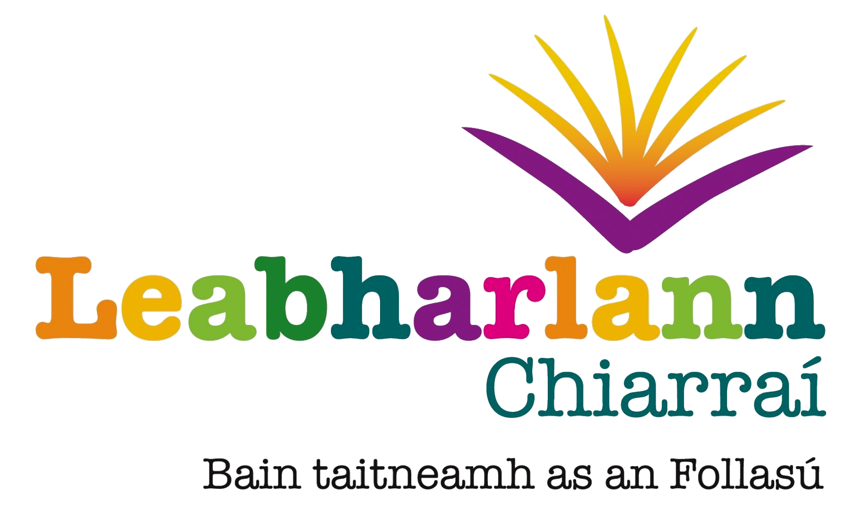Kerry Library Mobile Library Schedule
July and August 2017

Day | Route | Time
Monday 17 July  Route 6 | Rahoonane  Kilflynn  Shanakill C.C. | 12:30 - 1:45  2:00 - 3:15  3:45- 4:15
Tuesday 18 July  Route 7 | Glens  Feothanach  Bóthar Búi  Muiríoch  Lios Póil | 10:30 - 11:00  11:15 - 11:45  12:00 - 12:20  12:30 - 1:15  2:30 - 3:45
Wednesday 19 July  Route 8 | Duagh Village  Duagh R.C.  Moyvane  Tarbert Creché  Tarbert Village  Ballylongford Church  Ballylongford Heaphy's Shop  Asdee | 9:45 - 10:15  10:15 - 10:45  11:30 - 12.00  12:15 - 12:30  12:30 – 1:00  1:15 - 1:30  1:30 -1.45  2:30 - 3:30
Thursday 20 July  Route 9 | Ballydwyer  Currow  Brosna  Knocknagoshel  Lyreacrompane Resource Centre | 9:15 - 9:45  10:15 - 11:00  11:45 - 1:00  2:00 - 2:30  3:00 - 3:45
Monday 24 July  Route 1 | Rahoonane  Caherina  Spa Road  Oakview Village | 12:30 - 1:45  2:00 - 2:45  2:45 - 3:15  3:30 - 4:15
Dé Máirt 25 Iúil  Slí 2 | Ceann Trá  Halla Ceann Trá  Dún Chaoin  Baile an Fheirtéaraigh | 10:30 - 11:00  11:00 - 11:30  12:00 - 12:45  1:45 - 2:45
Wednesday 26  Route 3 | Ballyheigue  Causeway  Causeway Church  Abbeydorney C.C.  Lixnaw  Finuge | 9:45 - 10:45  11:10 - 11.30  11:30 - 12:00  1:15 - 2:15  2.30 - 3.30  3:45 - 4:00
Thursday 27  Route 4 | Blennerville  Fenit  Ardfert St. Road  Ardfert Village  Kilmoyley Church  Kilmoyley C.C.  Ballyduff | 9:15 - 10:00  10:30 - 11:30  11:45 - 12:00  12:00 - 12:30  1:30 - 2:00  2:00 - 2:30  3:00 - 3:45
Friday 28 July  Route 5 | Camp  Aughacasla  Castlegregory  Stradbally  Cloghane  Brandon | 9:30 - 10:00  10:15 - 10:45  11:00 - 12:00  12:10 - 12:30  1:30 - 2:30  2.45-3.30

August 2017

Please note the Mobile Library will be off the road from 31 July-11 August inclusive

Day | Route | Time
Monday 14 August  Route 1 | Kilcummin C.C  Kilcummin  Deerpark  Ballyspillane  Woodlawn | 11.15 - 11.45  11.45 - 12.45  1.45 - 2.15  2.30 - 2.45  3.00 - 4.00
Tuesday 15 August  Route 2 | Glenbeigh C.C  Glenbeigh Village  Dungeagan  Ballinskelligs (carpark)  Waterville  Waterville C.C  Kells | 10.00 - 10.30  10.30 - 10.45  11.45 - 12.15  12.15 - 12.30  1.45 - 2.15  2.15 - 2.45  3.30 - 3.45
Wednesday 16 August  Route 3 | Bonane  Tuosist  Lauragh  Kilgarvan | 10.45-11.15  11.45-12.30  12.45-1.30  3.00 -3.30
Thursday 17 August  Route 4 | Scartaglin C.C  Gneeveguilla  Rathmore P.O.  Rathmore N.S/Church  Rathmore Soc Centre | 9.45 - 10.15  10.45 - 11.15  11.30 - 12.10  1.00- 3.00  3.15 - 4.00
Friday 18 August  Route 5 | Castlemaine  Castlemaine C.C  Boolteens  Keel C.C  Ballyarkane  Inch  Annascaul | 9.30 - 10.30  10.30- 11.15  11.25 - 11.45  11.50 - 12.15  12.25 - 12.45  1.00 - 1.30  2.45 - 3.45
Monday 21 August  Route 6 | Farranfore  Knockanes  Glenflesk  Barraduff  Barraduff Church | 11.00 - 11.30  12.00 - 12.45  1.00 - 1.30  2.30 - 3.30  3.30 -4.00
Tuesday 22 August  Route 7 | Caherdaniel  Caherdaniel H.C.  Castlecove  Sneem N.S.  Sneem Square | 11.15-11.35  11.40-12.10  12.30 - 1.00  2.15 - 2.45  2.45 - 3.15
Wednesday 23 August  Route 8 | Portmagee C.C  Portmagee  Chapeltown C.C  Chapeltown Church  Knightstown  Cromane C.C | 11.00 - 11.15  11.15 - 11.55  12.00 - 12.45  12.45 - 1.00  1.15 - 1.45  3.45 - 4.15
Thursday 24 August Route 9 | Firies  Milltown Square  Milltown  Listry C.C  Fossa  Beaufort | 9.30 - 10.30  10.45 - 11.15  11.15-12.15  12.30 - 12.45  1.45 - 2.45  3.00.-3.45
Monday 28 August  Route 6 | Rahoonane  Kilflynn  Shanakill C.C. | 12:30 - 1:45  2:00 - 3:15  3:45- 4:15
Tuesday 29 August  Route 7 | Glens  Feothanach  Bóthar Búi  Muiríoch  Lios Póil | 10:30 - 11:00  11:15 - 11:45  12:00 - 12:20  12:30 - 1:15  2:30 - 3:45
Wednesday 30 August  Route 8 | Duagh Village  Duagh R.C.  Moyvane  Tarbert Creché  Tarbert Village  Ballylongford Church  Ballylongford Heaphy's Shop  Asdee | 9:45 - 10:15  10:15 - 10:45  11:30 - 12.00  12:15 - 12:30  12:30 – 1:00  1:15 - 1:30  1:30 -1.45  2:30 - 3:30
Thursday 31 August  Route 9 | Ballydwyer  Currow  Brosna  Knocknagoshel  Lyreacrompane Resource Centre | 9:15 - 9:45  10:15 - 11:00  11:45 - 1:00  2:00 - 2:30  3:00 - 3:45

Telephone: Mobile Library 1: 087-2896998, Mobile Library 2: 087-6656412
email: mobiles@kerrylibrary.ie, website: www.kerrylibrary.ie

